We will build 3 sections just like your screenshot:
- Top KPI Cards
- Category & Rating Charts
- Trend and Product Analysis

1️⃣ Import Dataset into Power BI
- Open Microsoft Power BI
- Click Home → Get Data
- Select CSV
- Choose the Amazon Sales Dataset
- Click Transform Data
Clean the data in Power Query
Check:
Column | Data Type
Product ID | Text
Product Name | Text
Category | Text
Actual Price | Decimal
Discounted Price | Decimal
Discount Percentage | Percentage
Rating | Decimal
Rating Count | Whole Number
- Remove null columns( mentioned as filtered rows) – ( rating count column): Right click the column name → remove columns.
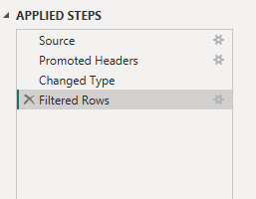
2.There was an error where Rating column had a wrong data type. 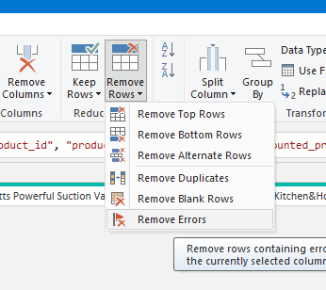
Click Close & Apply

2️⃣ Create Important Measures (DAX)
Go to Modeling → New Measure
Total Products
Total Products = DISTINCTCOUNT(Amazon[Product ID])
Average Rating
Avg Rating = AVERAGE(Amazon[Rating])
Total Reviews
Total Reviews = SUM(Amazon[Rating Count])
Average Discount
Avg Discount = AVERAGE(Amazon[Discount Percentage])
Total Categories
Total Categories = DISTINCTCOUNT(Amazon[Category])

3️⃣ Dashboard Layout (Like Netflix Example)
Your dashboard will have 3 rows.

🔴 Row 1 – KPI Cards
Insert Card Visuals
Add these fields:
Card | Field
Total Products | Total Products
Avg Rating | Avg Rating
Total Reviews | Total Reviews
Avg Discount | Avg Discount
Total Categories | Total Categories
Example layout
--------------------------------------------------
| Total Products | Avg Rating | Reviews | Discount |
--------------------------------------------------

4️⃣ Row 2 – Category & Rating Analysis
📊 Chart 1 – Products by Category
Visual: Bar Chart
Axis
Category
Values
Product ID (Count)
This shows which category has the most products.

⭐ Chart 2 – Rating Distribution
Visual: Column Chart
Axis
Rating
Values
Product ID (Count)
Shows how many products fall into each rating level.

💰 Chart 3 – Average Price by Category
Visual: Bar Chart
Axis
Category
Values
Actual Price (Average)
Shows most expensive product categories.

5️⃣ Row 3 – Product & Discount Analysis
🛒 Chart 4 – Top 10 Products by Reviews
Visual: Bar Chart
Axis
Product Name
Values
Rating Count
Filter:
Top N = 10

📉 Chart 5 – Discount Analysis
Visual: Bar Chart
Axis
Category
Values
Discount Percentage (Average)
Shows which category gives the highest discounts.

6️⃣ Add Filters (Important)
Insert Slicers
Add:
- Category
- Rating
- Discount %
This makes the dashboard interactive.

7️⃣ Design Like the Netflix Dashboard
To match your screenshot style:
Theme:
- Background → Dark grey
- Charts → Orange / Red
- Font → Segoe UI
Add title:
Amazon Product Sales Analysis Dashboard

8️⃣ Final Dashboard Structure
------------------------------------------------
| Total Products | Avg Rating | Reviews | Discount |
------------------------------------------------
| Products by Category | Rating Distribution |
------------------------------------------------
| Top Products by Reviews | Discount by Category |
------------------------------------------------

9️⃣ Insights You Can Write (For LinkedIn)
Example insights:
📊 Key Insights
• Amazon has 1000+ products across multiple categories
• Most products have ratings between 4.0 and 4.5
• Electronics and Home categories dominate the catalog
• Some categories offer higher average discounts
• A small number of products receive majority of customer reviews

🔟 Tools Section
Add this to your project:
Tools Used
- Microsoft Power BI
- Data Cleaning
- Data Transformation
- Data Visualization
- Dashboard Design

💡 Very important tip for you, Divya:
To impress recruiters, add 1 more page in the dashboard:
Page 2: Customer Review Analysis
This makes the project look much more advanced.

